Handling Missing Data

Definition
# Source: AI Source: Provided by: [Data Path: Persons Table -> ID Column: 1, Name_En Column: Motasem Essam] -> From: [Chatgpt (GPT‑5 Mini)] on [12/10/2025]
Handling Missing Data is the process of detecting and managing incomplete or missing values in a dataset to ensure accurate analysis.
- Missing data occurs when some fields in a dataset have no recorded value.
- This technique helps improve data quality and reliability before performing analysis.

Key idea:
# Source: AI Source: Provided by: [Data Path: Persons Table -> ID Column: 1, Name_En Column: Motasem Essam] -> From: [Chatgpt (GPT‑5 Mini)] on [12/10/2025]
It is like filling in missing information in a form or deciding how to handle incomplete answers.

Characteristics of Handling Missing Data
# Source: AI Source: Provided by: [Data Path: Persons Table -> ID Column: 1, Name_En Column: Motasem Essam] -> From: [Chatgpt (GPT‑5 Mini)] on [12/10/2025]
- Identifies empty or null values in datasets
- Ensures datasets are complete and usable for analysis
- May involve removing, replacing, or estimating missing values
- Helps prevent errors in calculations or statistical analysis
- Often performed during data cleaning or preprocessing

Methods for Handling Missing Data

1. Removing Records with Missing Values
# Source: AI Source: Provided by: [Data Path: Persons Table -> ID Column: 1, Name_En Column: Motasem Essam] -> From: [Chatgpt (GPT‑5 Mini)] on [12/10/2025]
If a record has too many missing values, it may be removed from the dataset.
Example:
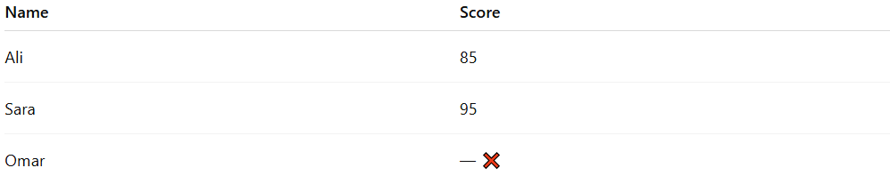
Name | Score
Ali | 85
Sara | 95
Omar | — ❌
After removing missing data:
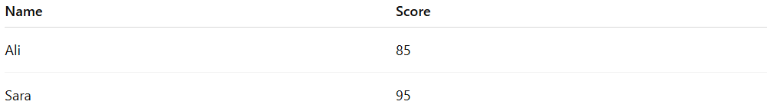
Name | Score
Ali | 85
Sara | 95

2. Replacing with a Default Value
# Source: AI Source: Provided by: [Data Path: Persons Table -> ID Column: 1, Name_En Column: Motasem Essam] -> From: [Chatgpt (GPT‑5 Mini)] on [12/10/2025]
Missing values can be replaced with a specific value such as 0, “Unknown”, or “N/A”.
Example:
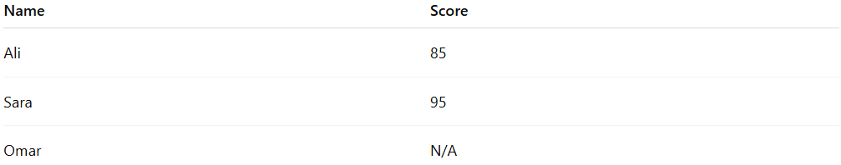
Name | Score
Ali | 85
Sara | 95
Omar | N/A

3. Filling with Average or Median
# Source: AI Source: Provided by: [Data Path: Persons Table -> ID Column: 1, Name_En Column: Motasem Essam] -> From: [Chatgpt (GPT‑5 Mini)] on [12/10/2025]
Missing numeric values can be replaced with the average or median of existing values.
Example:
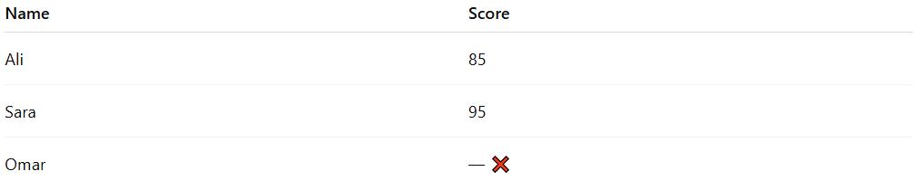
Name | Score
Ali | 85
Sara | 95
Omar | — ❌
Average = (85 + 95) / 2 = 90
After filling:
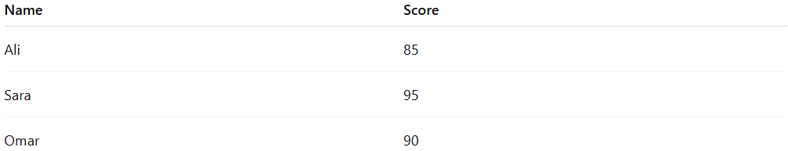
Name | Score
Ali | 85
Sara | 95
Omar | 90

4. Estimating Based on Related Data
# Source: AI Source: Provided by: [Data Path: Persons Table -> ID Column: 1, Name_En Column: Motasem Essam] -> From: [Chatgpt (GPT‑5 Mini)] on [12/10/2025]
Missing values can sometimes be estimated using related fields or patterns.
Example:
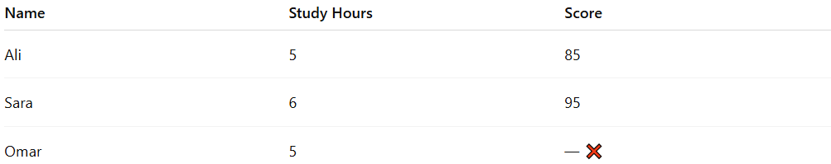
Name | Study Hours | Score
Ali | 5 | 85
Sara | 6 | 95
Omar | 5 | — ❌
Since students with 5 hours study scored around 85, Omar’s score may be estimated near 85.

Example Section
# Source: AI Source: Provided by: [Data Path: Persons Table -> ID Column: 1, Name_En Column: Motasem Essam] -> From: [Chatgpt (GPT‑5 Mini)] on [12/10/2025]
Original dataset:
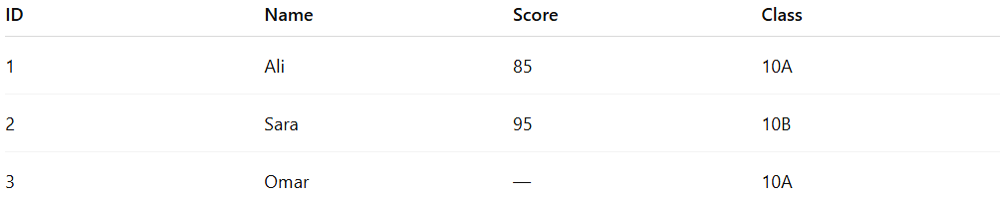
ID | Name | Score | Class
1 | Ali | 85 | 10A
2 | Sara | 95 | 10B
3 | Omar | — | 10A
Cleaning process:
- Identify missing value in Omar’s score
- Replace with the average score
Average score = (85 + 95) / 2 = 90
Cleaned dataset:
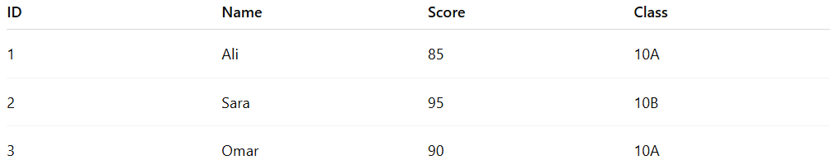
ID | Name | Score | Class
1 | Ali | 85 | 10A
2 | Sara | 95 | 10B
3 | Omar | 90 | 10A

Advantages
# Source: AI Source: Provided by: [Data Path: Persons Table -> ID Column: 1, Name_En Column: Motasem Essam] -> From: [Chatgpt (GPT‑5 Mini)] on [12/10/2025]
- Improves data completeness and usability
- Prevents errors during analysis or calculations
- Helps maintain dataset consistency
- Allows analysis even when some data is missing

Disadvantages
# Source: AI Source: Provided by: [Data Path: Persons Table -> ID Column: 1, Name_En Column: Motasem Essam] -> From: [Chatgpt (GPT‑5 Mini)] on [12/10/2025]
- Removing records may reduce dataset size
- Replacing values may introduce bias or inaccuracies
- Estimations may not always reflect the real value
- Requires careful selection of the appropriate method

